Ambrose and Joshua Saunders

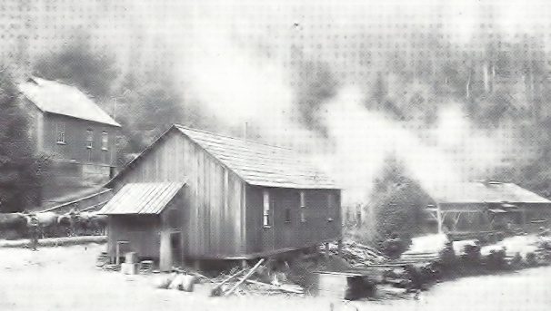
Ambrose and Joshua Saunders came to California in 1862. Ambrose quickly became recognized as a community contributor. He enlisted in the Jefferson Cavalry as 2nd Sergeant in the quartermaster Corps. The brothers had stopped in the gold fields in Northern California before traveling south to San Mateo County. They were not without money following their gold country visit and were able to afford investments in property in the lumber country towards the top of the mountain where the redwoods were growing so beautifully. Ambrose invested originally in property on Corte Madera Creek only several hundred yards from Madera Creek’s intersection with Tunitas Creek. He was able to purchase a mill that was originally called, and owned by, Eugene Fromont who was credited with building the Summit Springs Hotel and starting the Summit Springs Township.
Joshua Saunders purchased property farther down Tunitas Creek close to the western end of the creek. Joshua emphasized making shingles while Ambrose made whole lumber cutting boards of construction length to be used primarily in San Francisco where the city was being burned down, to some extent, by arsonists on a regular basis. The brothers used oxen to haul the lumber and shingles up Tunitas Creek to Summit Springs, about ½ mile east of the top of the hill, (today’s Skyline Boulevard) and stop at Summit Springs where they spent the night. They then hooked up two wagons to four horses in summer and six horses in winter and hauled them down the road, now called King’s Mountain Road, to Red Woods Road, now Woodside Road and east to Redwood City where they were unloaded at the Hanson and Ackerson Lumber Docks. The Saunders brother’s mills were highly productive and so were the Hanson and Ackerson shipping docks.
Joshua Saunder’s mill on Tunitas Creek.
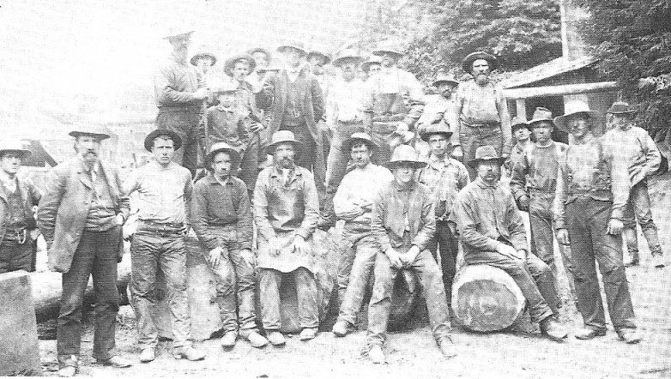
The brothers were living in Redwood City and they could observe the multiple numbers of ships that came into the Redwood Creek channel and sailed into the turning basin. Then, in the morning, when they were free from the bottom mud by the incoming tide, they would sail to the docks, be loaded with lumber and sail off to San Francisco, Stockton, San Jose, or wherever they were needed and off load the milled lumber.
Ambrose Saunders established lumber docks on Redwood Creek across from the Hanson and Ackerson docks and started to ship a substantial number of loads, cutting into their competitor’s business. This went on for several months before Charles Hanson decided to purchase both the docks and the mill on Corte Madera Creek for $3,000, (a substantial sum in those days). But, Ambrose had to agree and sign papers stating that he would not engage in the lumber business for the next three years. He was faithful to this agreement but three years and one day later he was hard at work at cutting lumber again along the top of the hill.
Joshua Saunders and his crew, Joshua is the tall man on the left.
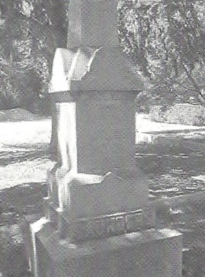
When the Saunders brothers first came to San Mateo County they settled in the Town of Searsville, the largest town in San Mateo County at the time. The county was established in 1856. The brothers moved, not long after, to Redwood City as it was growing rapidly. It was during this period that they observed the opportunity to build docks etc. While in Redwood City Joshua met and married Susan M. Saunders who had come to California from her native Maine as a young girl. Susan taught school in the Redwood Elementary School System until Joshua died in January of 1886. She then moved to Petaluma to live with her daughter Fannie.
Ambrose Saunders and Joshua Saunders died in January 1886, Ambrose is buried in plot 188 and Joshua is in plot 167. The brothers have identical large monuments in Union Cemetery. Both of the monuments had to be repaired after the years of vandalism the cemetery suffered during the 1970s and 1980s. These are two of the monuments that V. Fontana and sons repaired when we first began working on revitalizing Union Cemetery.

